**FOR IMMEDIATE RELEASE**

**[MOTI](http://www.nowmoti.com) Donated Generous Help to Paraguay’s Fire Department to Help Them Enhance Their Fire Fighting Capability**

*The Move Came in the Wake of Recent Rise in Fire Incidents Throughout the World and the Grey Areas in Fire Fighting Operations*.

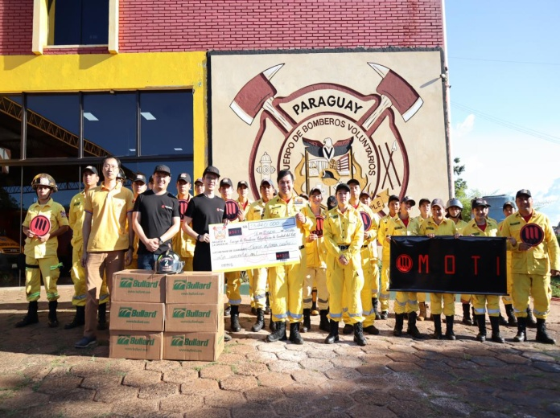**Las Vegas, USA, Jan 2020 –** MOTI, a leading e-cigarette company, the customers with best flavors, pleasurable experience and environment friendly technology in the e-cigarette market. To achieve these milestones, the company is constantly trying hard to use the best raw ingredients, coupled with cutting edge technologies and the best designs. To provide the ultimate experience in taste, the company subjects its products to a rigorous process, carefully selecting the best ingredients and working hard to develop new flavors of e-liquids. These measures have given MOTI’s products a distinguished position in the e-cigarette market.

It is said, rather well said, that if charity prevails, earth would be a heaven and hell a fable. MOTI’s products are not only environment friendly but the company also strives hard to protect the environment from any possible disaster. Unlike e-cigarettes, traditional cigarette filters are full of tar, nicotine, and other toxins that leach into the ground, potentially affecting any organism that comes into contact with them. Butts pushed by rain into storm drains can make it into the ocean, where they can release their toxic chemicals, or get eaten by fish or birds. Most electronic cigarettes are reusable, meaning only a tiny amount of vapor needs to be refilled for each use. They are typically powered by reusable batteries, and are often charged via USB ports.

On August 20, 2019, the world was shocked by the fire reported by mainstream western media. Many rainforests were burned and rare animals and plants were burned. In addition, it caused a lot of pollution and chain ecological damage.

MOTI learned of this news and decided to help the South American firefighting operation. Subsequently, MOTI found the Paraguayan fire station that needed the most help through various channels and provided them with fire equipment support.

See the support video here:  
**<https://bit.ly/38FFpJh>**

Coincidentally, a series of disasters such as forest fires, Amazon fires, Australian fires, etc. have also occurred recently in Australia. Littering cigarette ends is a big reason. Every year, more than 4500 fires across Australia are caused by cigarettes and at least 77 people lost their lives in fires started by cigarettes between 2000 and 2005[1].

Record reveals that carelessly discarded cigarette butts are a frequent cause of fires. Over seven billion cigarette butts are discarded just across Australia every year. These carelessly discarded butts have potential for causing fires including bushfires that claim innocent lives and pose a perpetual threat to environment. It is frequently observed that the threats from fires increase manifold when people from all walks of life participate in fire fight operations that are not professionally trained and well equipped.

MOTI is deeply concerned about fires and therefore donated a batch of fire helmets to the Paraguayan Fire Department to help fire fighting operation and equip the participants with reliable and effective equipments. MOTI aims to improve risk management, save humanity from the scourge of fire and conserve environment for living species. The donated equipments, no doubt, are overwhelmingly supportive to fire fighters as well because the equipments enable them to work effectively and safely.

President of Paraguay Fire Agency, Mr. Andres Fernandez, expressed his gratitude in these words; “*We thank MOTI for their generous help, this is the first time we have received help from a foreign company since the fire started. Your supplies will be very useful for our work. Thanks again MOTI for your attention and help*”.

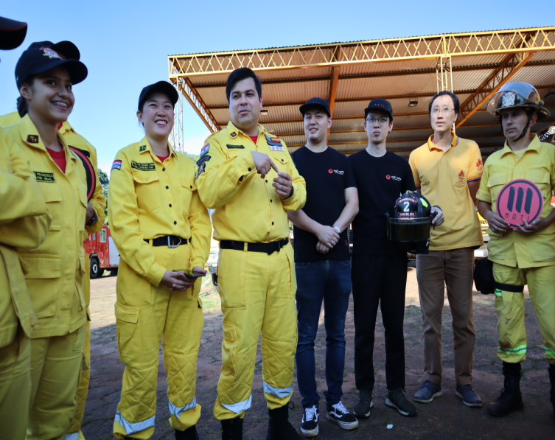The recent fires in Australia were horrendous. It taught us, “If you play with fire, you will get burned”. Avoid carelessly discarding cigarette butts as they are potential hell and can be catastrophic and disastrous. Today, risk management demands to rely more on safe products of MOTI. MOTI’s products offer a variety of flavors, keep the environment safe, thrive for mitigating the harmful effects of cigarettes and above all generously help those who are active in keeping this planet an abode worth living.

**Please, feel free to contact us if you have any query about MOTI’s products.**

**For more information, please visit: [www.nowmoti.com](http://www.nowmoti.com)**[1] Related statistics are quoted from www.fire.nsw.gov.au